HOW TO USE APPLICATION FLAGS
Authorized users will be able to flag applications in the Applicant Progress Dashboard of their job to better filter their applicant pool.
There are two ways to do so.
You can either go to the Applicant Progress Dashboard then select the ellipses on the far right of an applicant.
A menu will populate. Select Add flag.
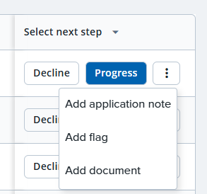
OR
You can go to the applicant card by clicking on the applicant then select the blue Add flags button located on their application rectangle.
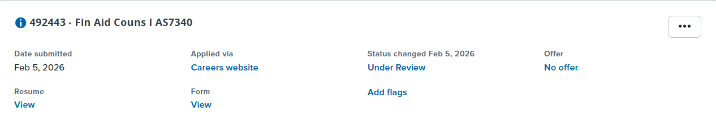
The flags of Yes, Maybe, and No will be options for you to select. The flags of Hired, Interview Scheduled, Finalist and Background check completed can also be used but will be automatically applied by the system throughout the recruitment process based on an applicant’s status. Check the box of the flag/s to apply the click submit.
NOTE: Flags are for information and visual use only, while application statuses permanently record the steps that every applicant went through. Please be sure to still progress applicant statuses.
NOTE: There are no limits to the flags, but the same flag cannot be added more than once to a specific application by separate users. There is one set of flags to use for each application. For instance, If I added Yes to an application, you would not be able to also add Yes. However, you would be able to add another flag/s option.
BONUS: Search committee chairs and search committee members will be able to see any application flags applied to applications through their search committee dashboard view. However, they will not be able to alter the flag/s.

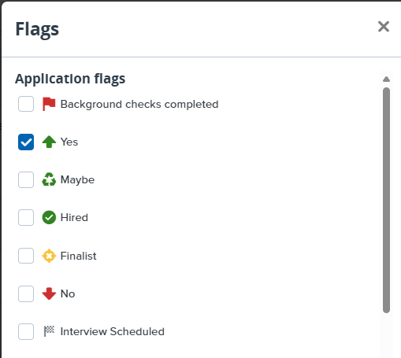
The flag symbol will then populate on the Applicant Progress Dashboard and the applicant card.
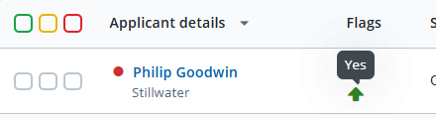
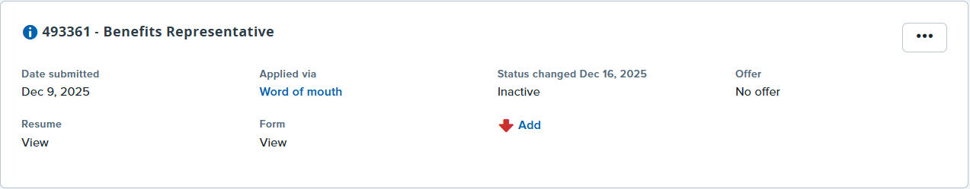
Following your flag selection, you will be able to filter the Applicant Progress Dashboard by each flag/s. Click the Filters button then the Flags drop-down and select your filter option. Scroll down and click Apply.
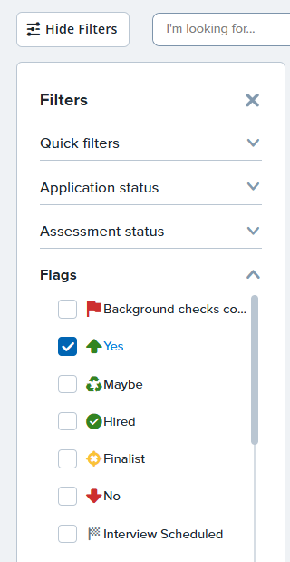
The Applicant Progress Dashboard now only shows applicants under that flag.
